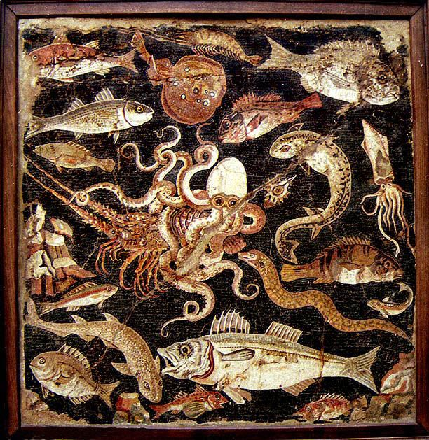
A Taste of the Sea
Friday 30th October – 7.00pm

*

Freshly Shucked Native Oysters
Honey, Soy & Spring Onion Dressing

*
Lemon & Dill Cornish Crab Cake
Crushed Peas & Mint, Salt & Vinegar Scraps

*
Aromatic Thai Mussels
Bangkok Chilli Toast

*
Lobster Thermidor & Confit Duck A L’Orange
Truffle Butter Mash, Escoffier Red Cabbage

*
Homemade Jam Sponge
Baileys Custard

£55

