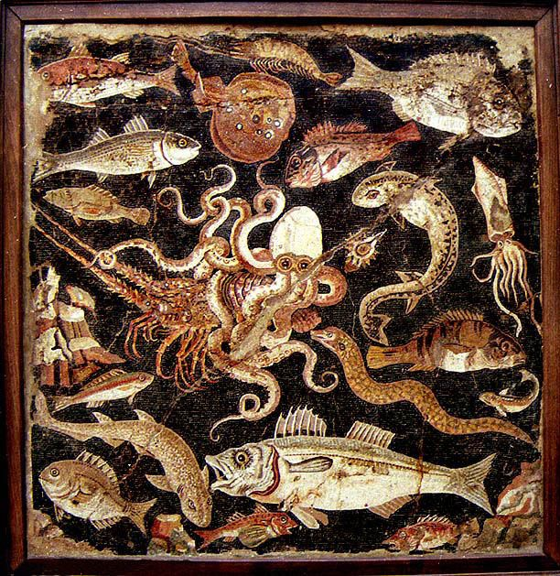
A Taste of the Sea
Friday 13th March – 7.00pm

*

Lobster & Ham Croquetas
Pimentón Salsa

*
Chilli, Parsley & Vermentino Mussels
Sicilian Squid Ink Spaghetti, Gremolata

*
Haddock Goujons
Homemade Chips, Crushed Peas & Mint, Homemade Tartare Sauce

*
Seared Scallops
Lemon Mash, Stornoway Black Pudding & Kale

*
Cadbury’s Mini Egg Cheesecake
Raspberry Ripple Ice Cream

£65

