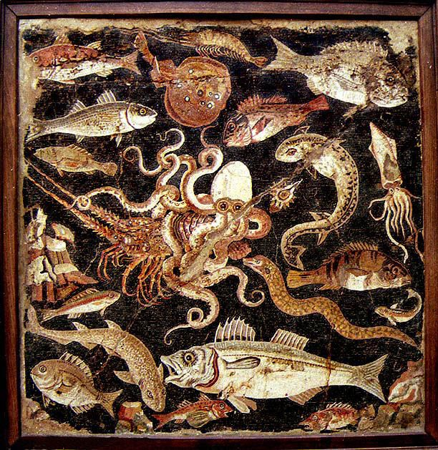
A Taste of the Sea
Friday 24th October – 7.00pm

*

Freshly Shucked Native Oysters
Sauvignon Blanc, Apple & Cucumber Dressing

*
Crispy Squid
Sicilian Squid Ink Spaghetti, Chilli Butter Sauce

*
Seabass & Caviar
Wilted Spinach, Pomme Puree, Caramelised Parsnip, Roasted Chicken Jus

*
Scottish Hake
Smoked Haddock & Mussel Veloute, Samphire

*
Biscoff Coconut Cheesecake
Chocolate Ice Cream
£55

