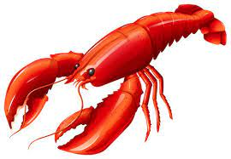

Lobster Special
13th – 16th February

Singapore Style Whole Lobster & Crab Spaghetti
Soy & Sesame Broccoli, Chilli Toast
£47.50
*

Whole Piri Piri Lobster & Prawns
Seasoned Fries, Portuguese Salad, Piri Piri Dipping Sauce
£47.50

*

Fresh Whole Lobster
Thermidor Sauce, Rocket & Red Onion Salad, Homemade Chips
£45

*

Thai Half Lobster
Crispy Bangkok Chicken, Red Curry Broth, Coconut Rice
£35

*

Char-Grilled Fillet Steak & Half Lobster
Homemade Chips, Pepper Sauce, French Bean Fricassee
£47.50

