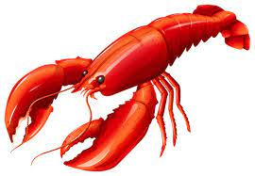

Festival of Lobster
14th – 18th February

Fresh Whole Lobster
Thermidor Sauce, Rocket & Red Onion Salad, Homemade Chips
£45

*

Thai Style Half Lobster
Crispy Bangkok Chicken, Red Curry Broth, Coconut Rice
£35

*

Char-Grilled Fillet Steak & Half Lobster
Homemade Chips, Pepper Sauce, French Bean Fricassee
£47.50

*

Burger & Lobster
Double Truffle Cheeseburger, Half Lobster, Skinny Fries, Onion Rings
£30

