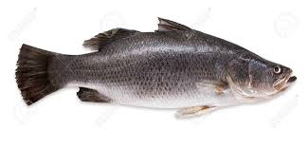
A Taste of
Cornwall
7.00pm
Friday 29th April

St Ives Crab Cake
Lemon Sauce

*
Scallop, Mussel & Prawn Potage
Charred Bread & Salted Cornish Butter

*
Line Caught Cornish Seabass
Cornish New Potatoes, Cauliflower Puree, Roasted Cauliflower, Asparagus, Green Herb Vinaigrette

*
Honey & Mustard Glazed Pork
Glazed Pork Fillet, Crispy Pork Belly, Carrot Puree, Roasted Apple,
Sausage Bon Bon, Savoy Cabbage, Cornish Cider Sauce, Crispy Sage

*
Strawberries & Clotted Cream
Pimms Macerated Strawberries, Clotted Cream Whip, Cornish Fairings Crumb,
Chocolate, Meringue, Strawberry Sorbet

£45

